**ST. XAVIER’S COLLEGE**

**(Affiliated to Tribhuvan University)**

**Maitighar, Kathmandu**



**OS LAB ASSIGNMENT #03**

**SUBMITTED BY:**

Pradeep Dahal

017BSCIT029

2nd year/ 4th sem

|  |  |
| --- | --- |
|  | Signature |
| Mr. Rabin Maharjan  (Lecturer) |  |
| Department of Computer Science | |

**SUBMITTED TO:**

## DEMOSTRATION OF LINUX COMMAND LINES:

### Linux Command Line

Graphical user interface operating system is user friendly at the first look but it is much faster and easier for larger or/and repeated operations in command line operating system than GUI operating system. Also command line operating system is helpful when we want know about background detail of the program or/and system system.

**Shell** is a program that takes the command form the key board and gives them to the operating system to perform.

**Terminal** is a tool which we use to pass the shell commands. It is the program that opens a window and let us interacts with the shell. Carl+Alt+t

**File system**

Files system in Linux operating system are organized in hierarchy order, that is tree like directory system. The main directory of the Linux operating system is root (/) directory and every other directories (bin, boot, carom, deb, etc, home, lib, says, run, use etc.) are in this root directory. In Linux operating system the present working directory is home directory where the user directory is located. In user directory there are other directories like desktop, downloads, documents, pictures, templates etc.

**Commands:**

pwd (Present working directory)

cd (change directory)

ls (list contents)

clear (clear the screen)

**1. ls command**

syntax:- **ls [option] [directory/file]**

1. **ls Documents** (list the contents of the documents directory)

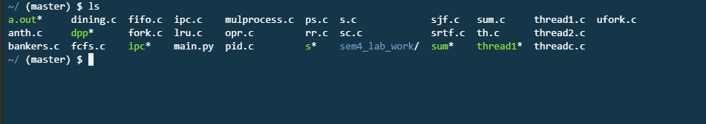

1. **ls ~** (list the contents of the home directory)

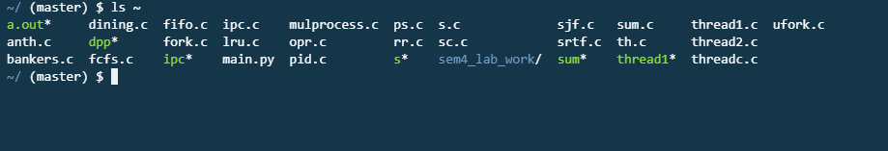

1. **ls ..** (list the contents of the one step back directory)

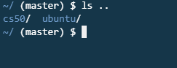

1. **ls ../..** (list the contents of the two steps back directory)

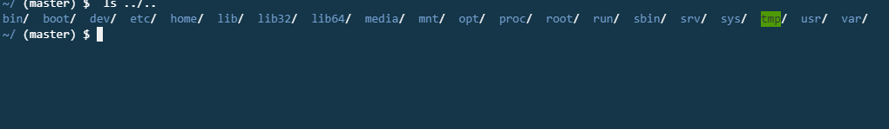

1. **ls -l** (list the contents of the directory in long format)

gives details abut rights, size, date and time

drawer-xr-x [owner-group-user] d:- directory r:-read w:-write x:-execution

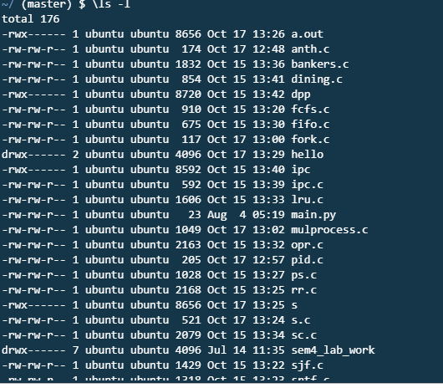

1. **ls -a** (list the contents of the hidden files of the directory)

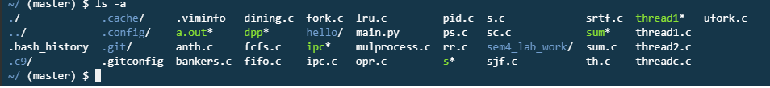

1. **ls -AL** (list the contents of the hidden files in long format of the directory)

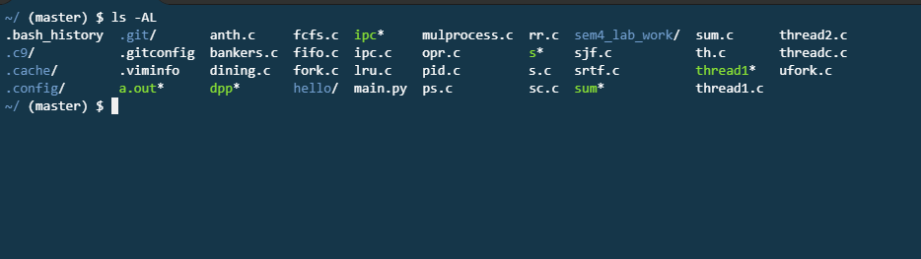

1. l**s -ls** (list the contents of the directory sorted by size)

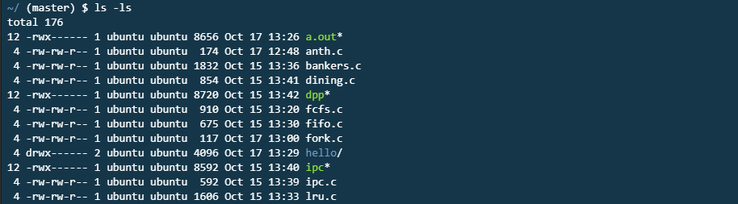

1. **ls Documents/*.\*** (list the contents of the documents directory with all the extensions)

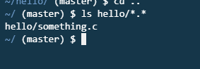

1. **ls -ls > outfox** (save the list of the directory in outfox text file)

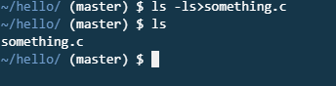

1. **ls -d */** (list only the directories of the directory)

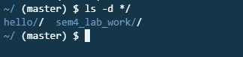

1. **man ls** (manual dictionary of ls command)

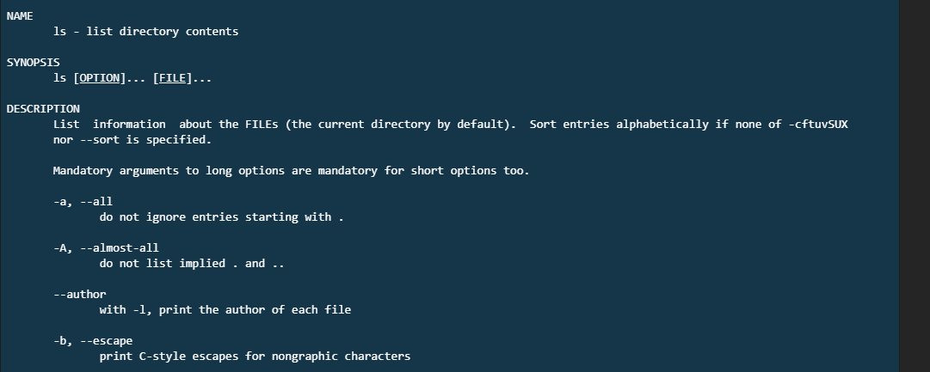

1. **q** (quit the terminal)



**2. CD command**

syntax:- **CD [directory]**

1. **CD** (change to home directory)
2. **CD /** (change to root directory)
3. **CD ~** (change to home directory)
4. **CD ..** (change to parent directory)

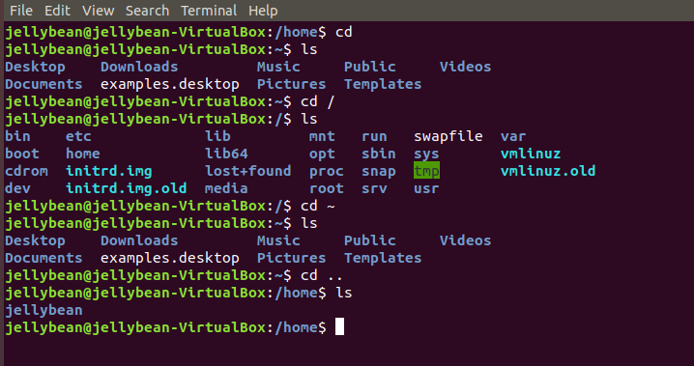

1. **CD Documents** (change to documents directory) *absolute or relative path*
2. **CD My\ Books** (change the directory with space in document name)
3. **CD ‘My Books’** (change the directory with space in document name)
4. **CD “My Books”** (change the directory with space in document name)

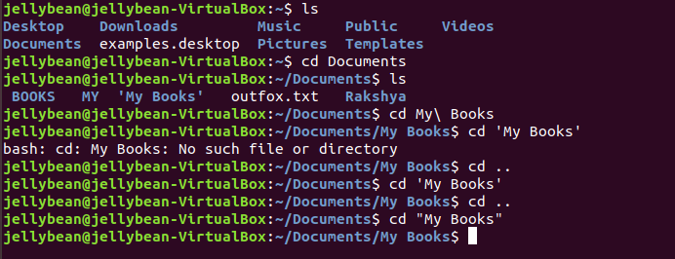

**3. cat command** (display, combine/copy and create text file)

syntax:- **cat [options] [file1,file2,…]**

1. **Cat**

hello world

1. **Ctrl+d** (out of cat command)
2. **cat list outfox** (display the contents of the outfox)
3. **cat list out.txt in.txt** (display the contents of the out.txt and in.txt)

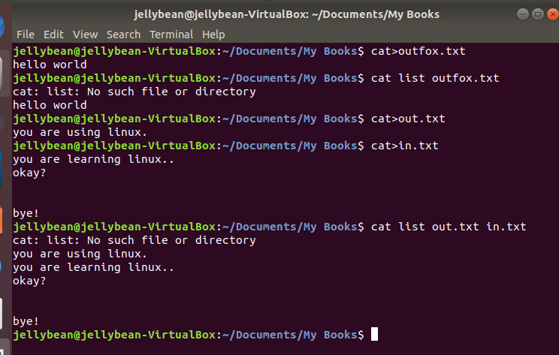

1. **cat -b out.txt** (display the contents of the out.txt with the line numbers in non blank lines)
2. **cat -n in.txt** (display the contents of the in.txt with the line numbers in all lines)
3. **cat -s in.txt** (display the contents of the in.txt with only one blank line even there are number of blank lines)
4. **cat -E in.txt** (display the $ sing at the end of every lines of the in.txt)

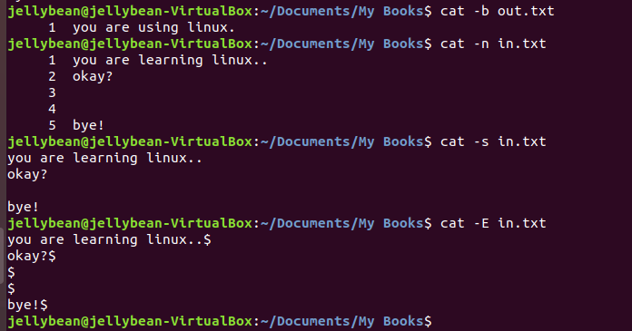

1. **man cat** (manual of cat command)

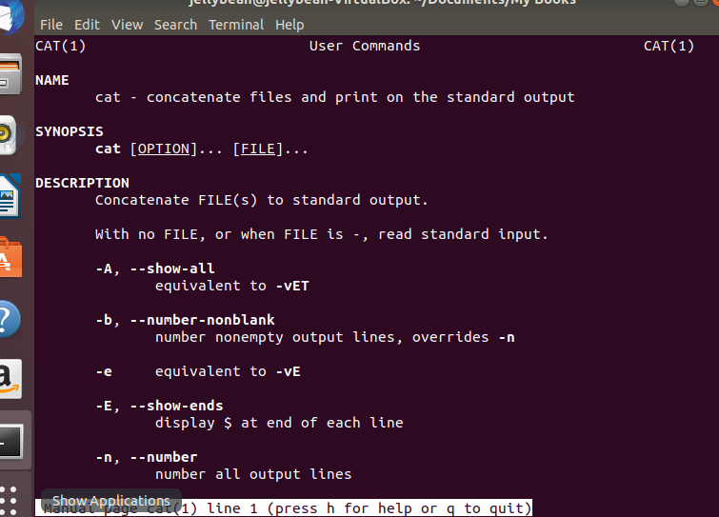

**4. I/O redirection** (capturing output from the file/program/command and send it as input to another file/program/command)

1. **output >file**
2. **cat > out.txt**

line 1

line 2

line 3

1. **Ctrl+d** (end of the file)
2. **cat out.txt** (display out.txt)
3. **cat > out.txt** (over write the file out.txt)

line 4

line 5

1. **Ctrl+d** (end of the file)
2. **cat out.txt** (display out.txt)
3. **cat >>out.txt** (add the new contents in the out.txt)

line 6

line 7

1. **Ctrl+d** (end of the file)
2. **cat out.txt** (display out.txt)

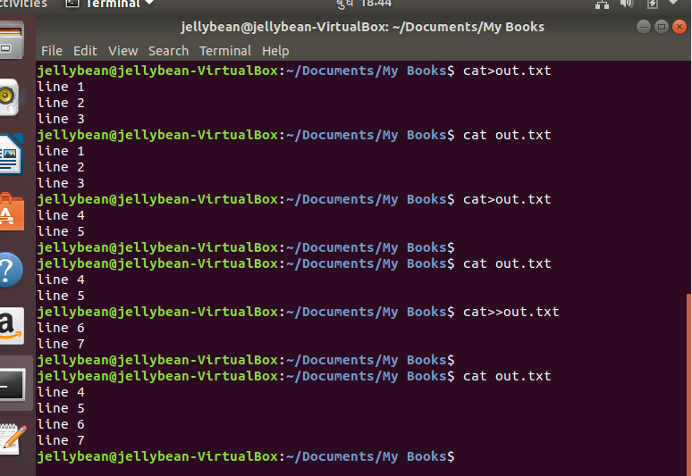

1. **cat out.txt in.txt > add.txt** (combine the contents of the file out.txt and in.txt and save to a new file add.txt)

cat add.txt (display add.txt)

1. **cat out.txt>> in.txt** (combine the contents of the out.ext and in.txt and save to a same old file in.txt)

cat in.txt (display in.txt)

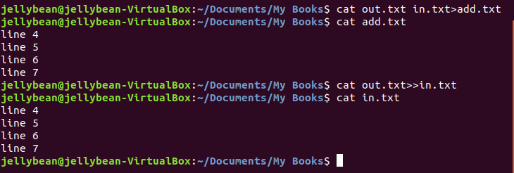

**5. mkdir** (creating a new directory)

1. **mkdir sxc** (creating a new directory sxc)

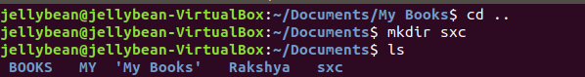

1. **mkdir sxc/os** (creating a new sub-direcoty os in present working directory sxc)

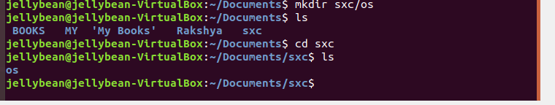

1. **mkdir -p department/computer** (creating a new directory department and creating a sub-directory computer under the department directory)

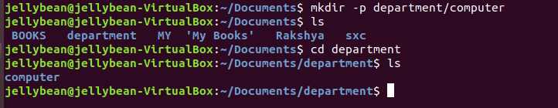

1. **mkdir --parents** **department/computer** (creating a new directory department and creating a sub-directory computer under the department directory)

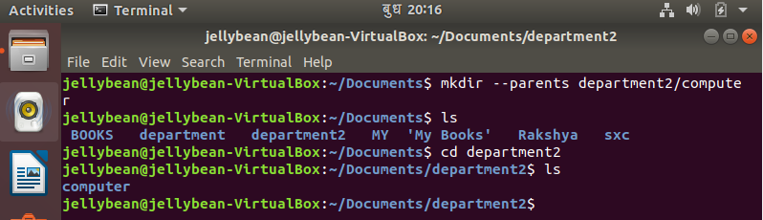

1. **mkdir -p science/{CSIT,BIM}** (creating a new directory science and creating muntiple sub-directories CSIT and BIM under the science directory)

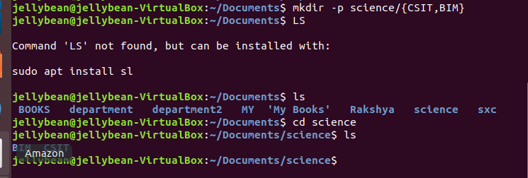

1. **mkdir -p science{CSIT,BIM}** (creating new directories scienceCSIT and scienceBIM)



**6. rmdir** (remove the directory)

syntax:- **rmdir [option] [dir name]**

1. **rmdir sxc** (remove the directory sxc)

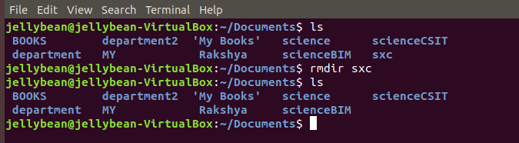

1. **rmdir sxc/os** (remove the sub-directory os under the directory sxc)

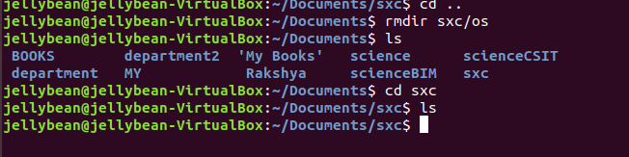

1. **rmdir -p sxc/os** (remove the sub-directory os as well as the root directory sxc)

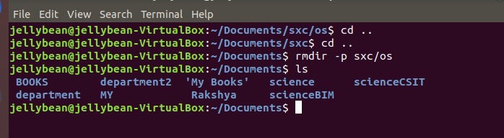

1. **rmdir -p science/{CSIT,BIM}** (remove the all sub-directories CSIT and BIM as well as the root directory science)

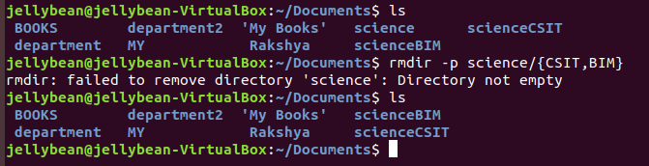

1. **rmdir -pv science/{CSIT,BIM}** (remove the all sub-directories CSIT and BIM as well as the root directory science and shows the removing process: *v verbose*)

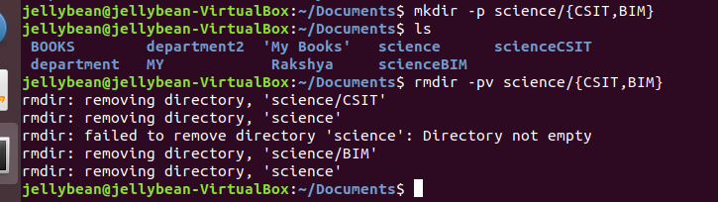

**7. rm** (remove the directory/file)

syntax:- **rm [option] [dir/file name]**

1. **mkdir -p a/b/c/d/e** (create a root of the directories a/b/c/d/e)
2. **cd a/b/**  ( change the working directory b)
3. **cat >abc.txt** (creating the new file abc.txt)
4. **This is the test.** (write a contents in abc.txt file)
5. **Ls -R** (list the roots of the directories)

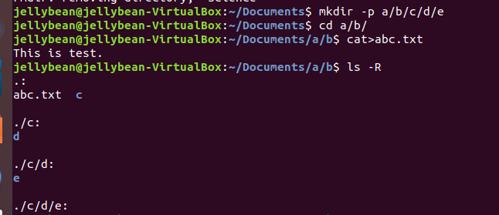

1. **rm -rv** **a** (remove all the tree directories and files:  *r recursive*)

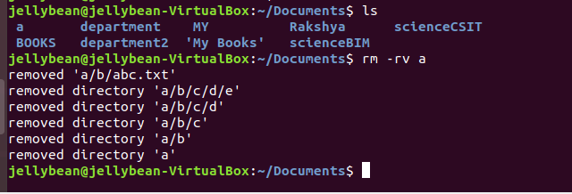

**8. cp** ( copy files/ directory)

syntax:- **cp [option] [source] [destination]**

1. **cp add.txt sub.txt** (copy the contents of add.txt and creat a new file sub.txt and pest the contents of add.txt in it)
2. **cat add.txt** (display the contents of add.txt)
3. **cat sub.txt** (display the contents of sub.txt)

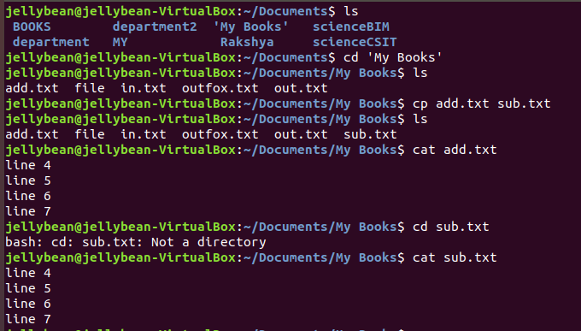

1. **cp add.txt sxc** (copy the file add.txt to the directory sxc)

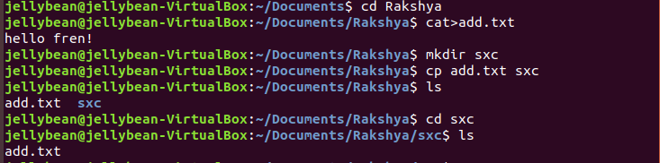

1. **cp in.txt out.txt sxc** (copy the file in.txt and out.txt to the directory sxc)

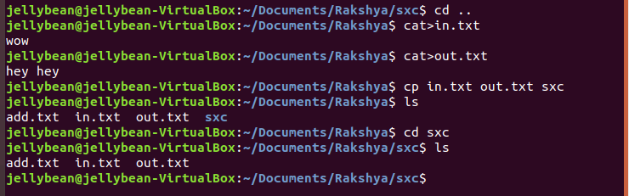

1. **cp -i in.txt sxc** (copy the file in.txt to the directory sxc: *i interactive; gives a options to over write*)

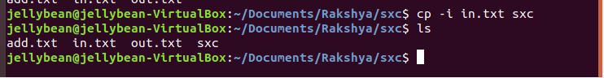

1. **cd sxc** ( change directory sxc)

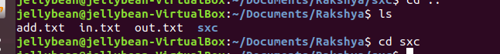

1. **cp ../in.txt ../out.txt .** (copy the files in.txt and out.txt to the current working directory: *. current working directory*)

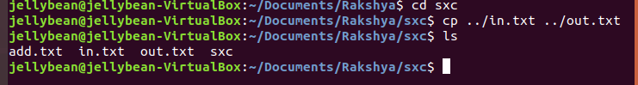

1. **ls -a** ( list the contents of current directory)

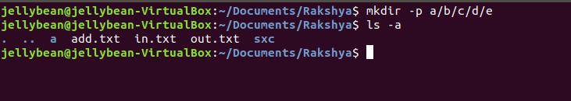

1. **cp -r sxc computer** (copy the contents of directory sxc and create a new directory computer then paste the contents in it)

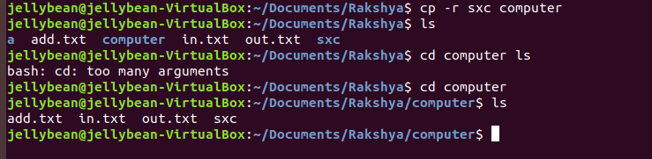

1. **cp -rv sxc computer** (copy the directory sxc into the directory computer which is already present)

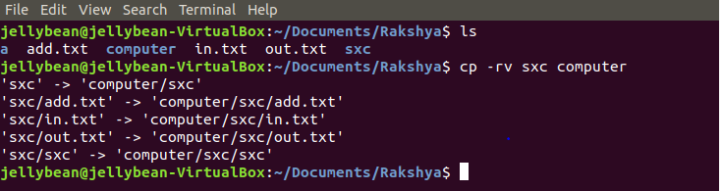

**9. mv** command (move)

syntax:- **mv [option] [source] [destination]**

1. **mv add.txt what.txt** (change fine name add.txt to what.txt)
2. **mv what.txt why.txt** (remove the file what.txt and move the contents in a new file why.txt)

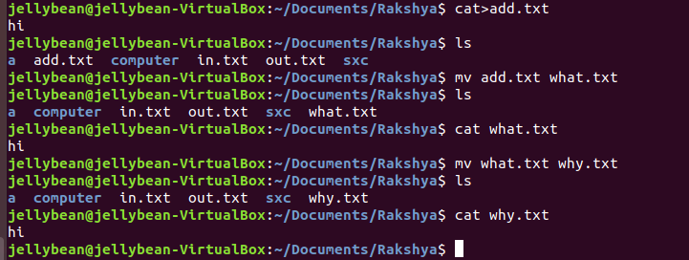

1. **mv why.txt sxc** (move the file why.txt to the directory sxc)

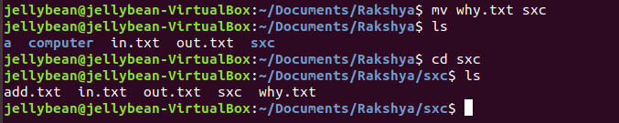

1. **cat >why.txt** (create a new file why.txt)
2. **mv why.txt sxc** (move the file why.txt to the directory sxc) *overwrite the contents*

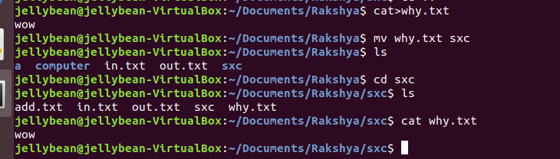

1. **mv -i why.txt sxc** (move the file why.txt to the directory sxc) gives a options to *overwrite the contents*

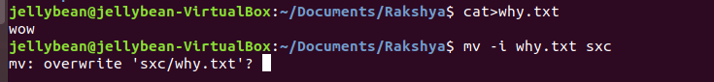

1. **mkdir how** (create a directory how)
2. **mv sxc how** (move the directory sxc to directory how): *transfer*

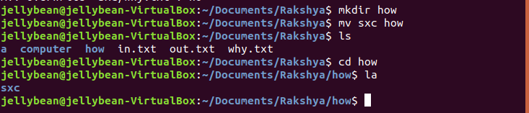

1. **mv sxc who** (create a new direcory who and paste the contents of directory sxc) *rename*

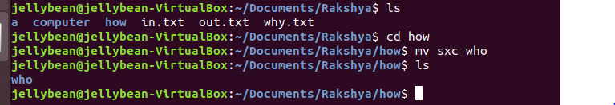

1. **man mv**

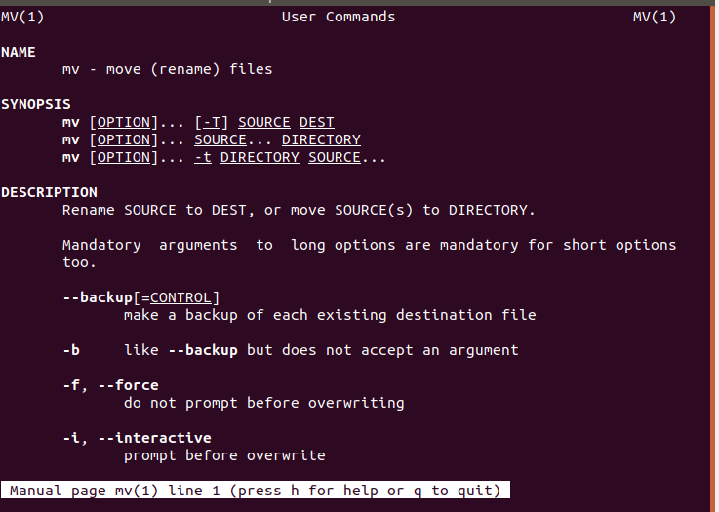

**10. less command**

1. **less file**

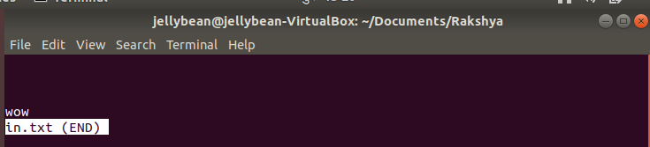

1. **down/ up** arrow gives line by line navigation

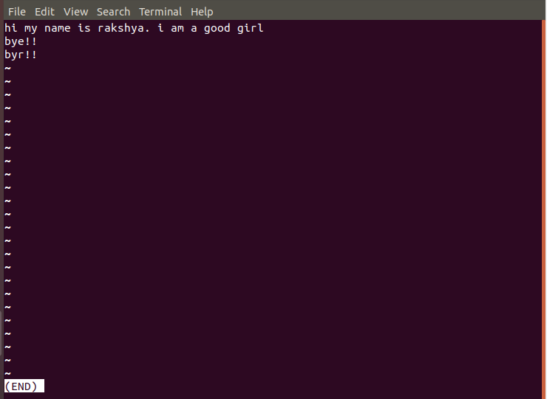

1. **space**/**B/D** gives page by page navigation

1. **G** navigate end of the file

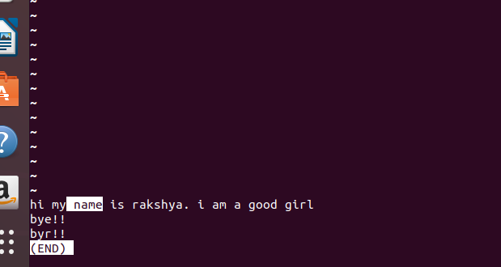

1. **1g** navigate top of the file
2. **/ word(name)** search the word form top to down page

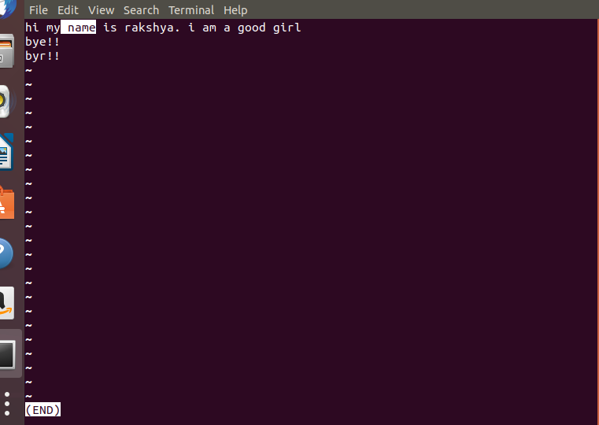

1. **n** for next page

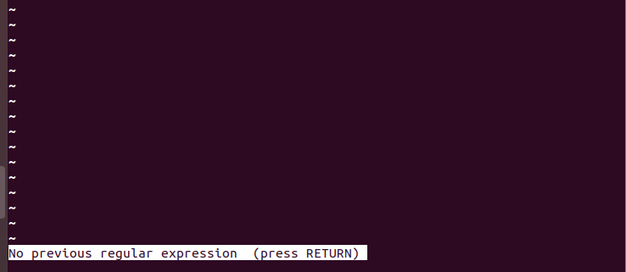

1. **?** **word(is)** search the word form down to up page

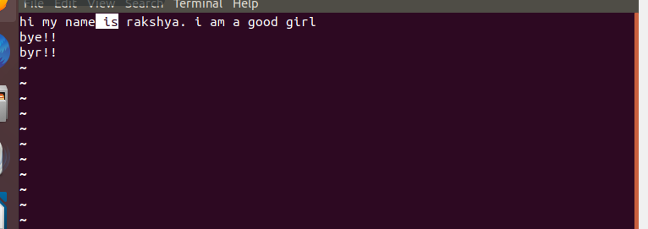

1. **Q** quit the less command

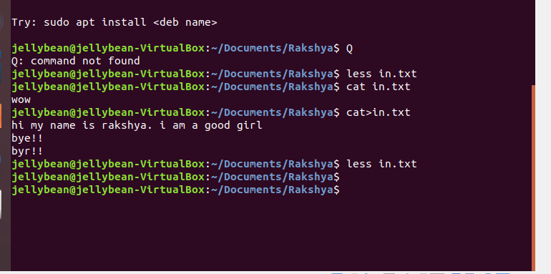

**11. touch** command (create new empty file/change the time stamp)

1. **touch file1** (create a file file1)
2. **touch file1.txt** (create a file file1.txt)
3. **touch file1.txt** (change the time stamp of the file file1.txt)

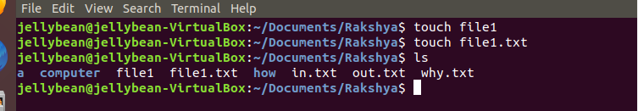

## Conclusion:

Hence, in this way Linux commands were demonstrated using Virtual Box.